Plotly and Cufflinks
Plotly is a library that allows you to create interactive plots that you can use in dashboards or websites (you can save them as html files or static images)

Install plotly and cufflinks
From cmd prompt
pip install plotly
pip install cufflinks
from plotly import __version__
from plotly.offline import download_plotlyjs, init_notebook_mode, plot, iplot
import cufflinks as cf
# For Notebooks
init_notebook_mode(connected=True)
# For offline use
cf.go_offline()

df = pd.DataFrame(np.random.randn(100,4),columns='A B C D'.split())
df2 = pd.DataFrame({'Category':['A','B','C'],'Values':[32,43,50]})

Using Cufflinks and iplot()
- scatter
- bar
- box
- spread
- ratio
- heatmap
- surface
- histogram
- bubble

Scatter
df.iplot(kind='scatter',x='A',y='B',mode='markers',size=10)
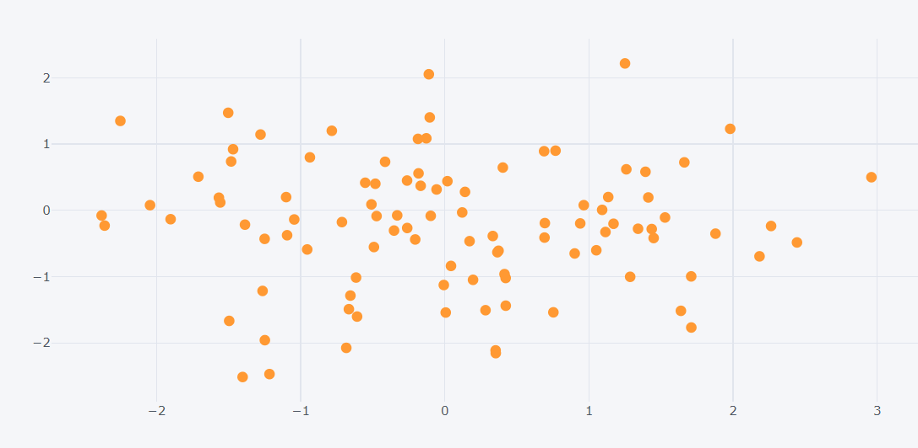
df2.iplot(kind='bar',x='Category',y='Values')
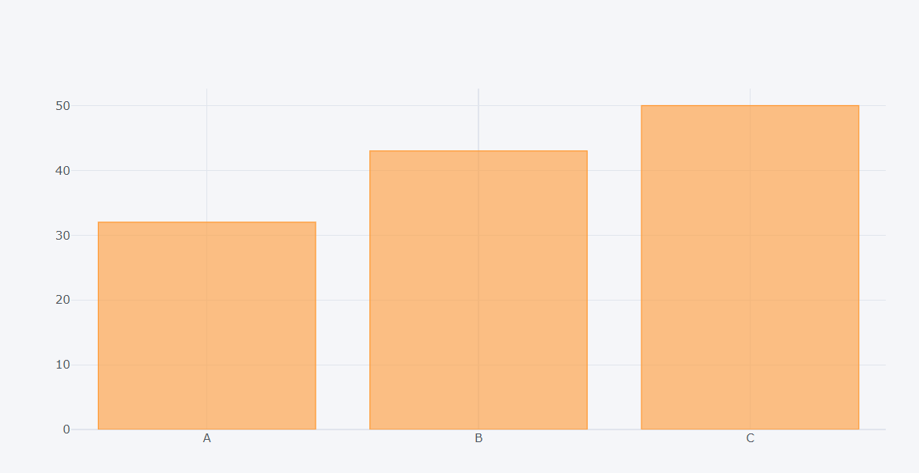
df.count().iplot(kind='bar')
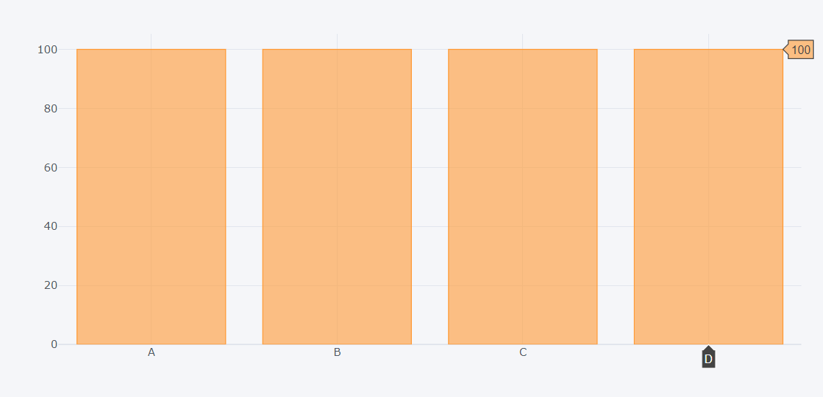
df.iplot(kind='box')
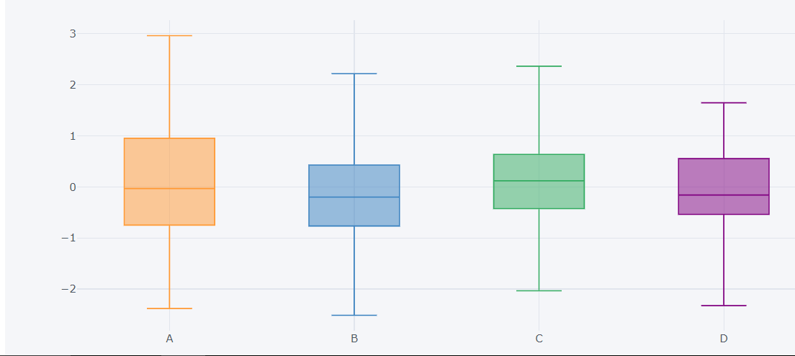

df3 = pd.DataFrame({'x':[1,2,3,4,5],'y':[10,20,30,20,10],'z':[5,4,3,2,1]})
df3.iplot(kind='surface',colorscale='rdylbu')
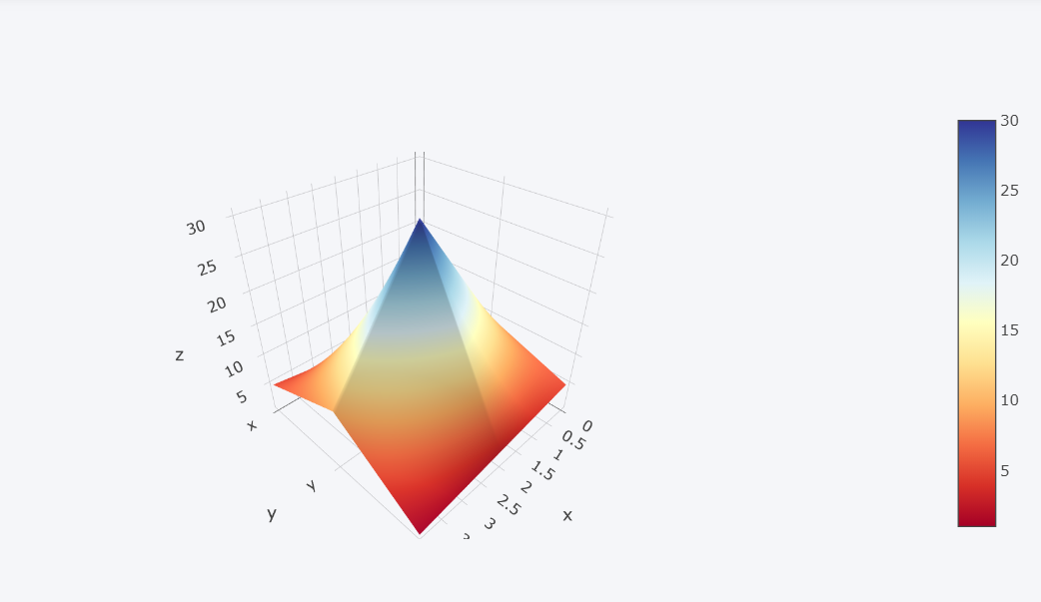

df[['A','B']].iplot(kind='spread')
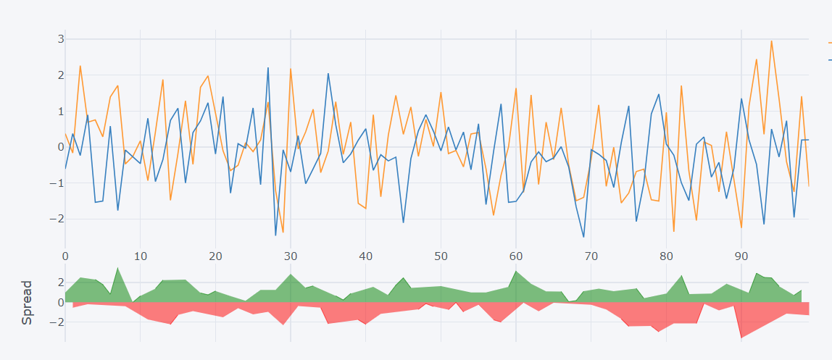
df ['A'].iplot(kind='hist',bins=25)
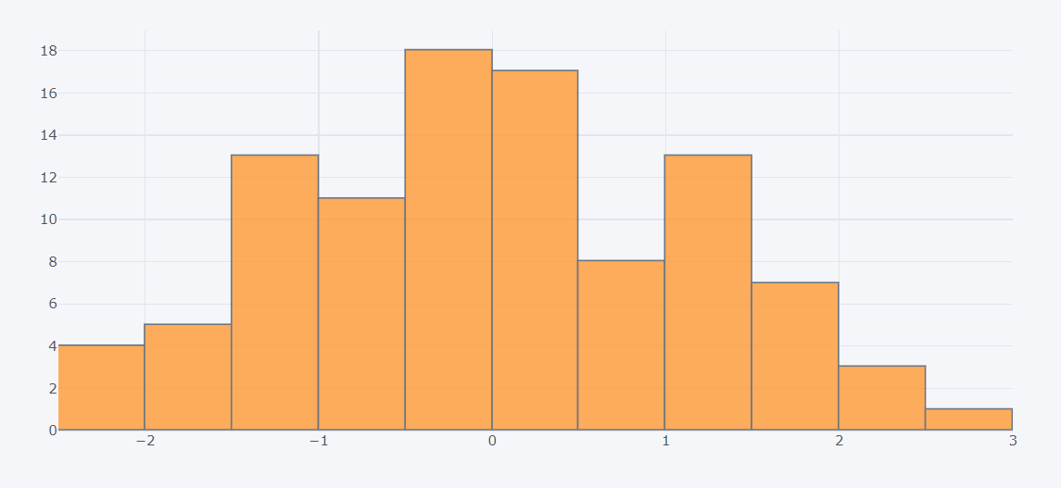

df.iplot(kind='bubble',x='A',y='B',size='C')
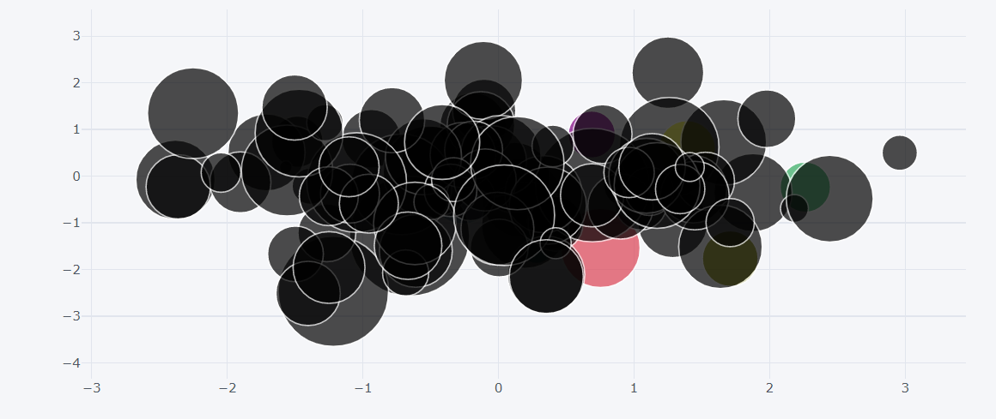

df.scatter_matrix()
